How to Win at SmartSims’ NetMike

Roger Smith
Titan Corporation
Orlando, Florida
http://www.modelbenders.com/

University of Maryland
MBA Program
Spring 2002

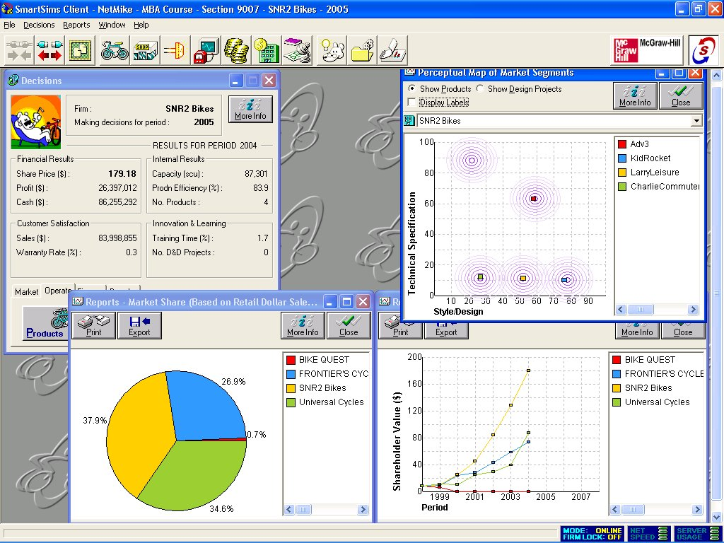
During the spring of 2002 the SNR2 Bicycle Company had a fantastic time playing NetMike (http://www.smartsims.com/) and turned in a pretty decent performance. We were able to increase the stock price of our company from $7.97/share to $179.18/share with a profit of $26,397,012. This is based on a four-team game that ran for six weeks with one turn each week. SmartSims informs us that the final results vary significantly when more teams are involved or the game is played for a longer period.

Figure 1. Final Results of SNR2 Bike Company using NetMike Simulation

This paper describes the strategies that our team used to achieve this result. We expect that results vary based on the decisions of the other teams in the simulated world. But, we also believe that following these steps will insure that a team will have excellent results. Looking back on some of our mistakes we believe that it would have been possible to achieve a stock price above $200/share and are slightly disappointed with ourselves for not reaching it. Perhaps we can help a future team to achieve this goal.

- Read the Manual


We were introduced to NetMike during a telecon with Dr. Edwards and Debra Kuyatt. Ms. Kuyatt encouraged us to read the entire NetMike manual in preparation for playing the game. This turned out to be an essential piece of advice. Like us, your team probably feels that since they are nearing the completion of their MBA, they know all of the answers. This is a folly that will land you in the NetMike poorhouse. Your MBA has familiarized you with the principles of business, but you are about to apply them in an environment that is much more complex than writing a research paper. You have to read the complete manual to understand how the NetMike world works.

Figure 2. The Essential Reference - Mike’s Bikes Manual

Though the complete manual is 168 pages long, there are several sections in the manual that have little application to playing the game. It appears to be written as a textbook for an MBA course in strategy. You will find yourself immersed in some of the formulas and tables of specific chapters. We will leave the discovery of which chapters those are up to you.

This manual is going to be your reference book for six weeks. We recommend that you print it out and bind it in a manner that makes it easy and convenient for you to flip through.

- Hundreds of Experiments

NetMike has two buttons on the menu bar that will become your best friends. These are labeled “Go” and “Back”. To really understand the relationships of variables in the simulation you will need to conduct many experiments. To use these buttons you must save the NetMike data to “Play Offline”. This allows you to experiment on your own computer without actually submitting your data to the NetMike server that resides somewhere out on the Internet.

We believe that it is best to change one variable, click the “Go” button to move to the next year, and read the reports and data to see how that variable affected the game. Then hit the “Back” button to move back to the previous state and experiment with that same variable some more or move on to another variable.

This sounds like it is going to be incredibly tedious and take a lot of time. Yes, it is! However, once you become immersed in the game, the tedium will be replaced with excitement and the hours will fly by.

Did he say “hours”? Yes, for each move I estimate that we conducted upward of 200 experiments with the input variables. In the beginning this required 4 hours to construct the best move for the team. It goes faster each week. But, you also become more proficient at subtle relationships and end up toiling over details that you did not even notice in earlier weeks.

Our approach treats the simulation as a learning tool. We did not look at it as a test of our business wisdom in setting the variables and allowing the simulation judge how smart we were. Instead, each experiment taught us something new about the relationships between price, advertising, PR, debt, equity, and R&D on each of the experiments. Our goal was to learn, not to test how smart we were.

If you have adolescent children you can compare experiments with NetMike to the hours they spend playing computer games. Through constant repetition your kids master the game and learn its subtleties. You are doing the same thing with hundreds of “Go” and “Back” sequences of operations. Also, it really is best to conduct these experiments by changing only one variable at a time. After a couple of weeks you will understand it well enough to change two or more at one time.

- Spreadsheet to Manage Inputs and Results

You are working as part of a distributed team exchanging e-mail about the move you want to make. You are also conducting hundreds of experiments with the simulation to determine the best move. How are you going to manage all of that data? You need to create a spreadsheet with all of the input variables and output variables on it. Ours contained a row for every input variable and every output variable found on the “Decisions” screen of NetMike. It contained a column for the variable labels and for each year of the simulation. We also included one set of rows for the results generated by our best offline experiment and another set for the actual results generated by the NetMike server.
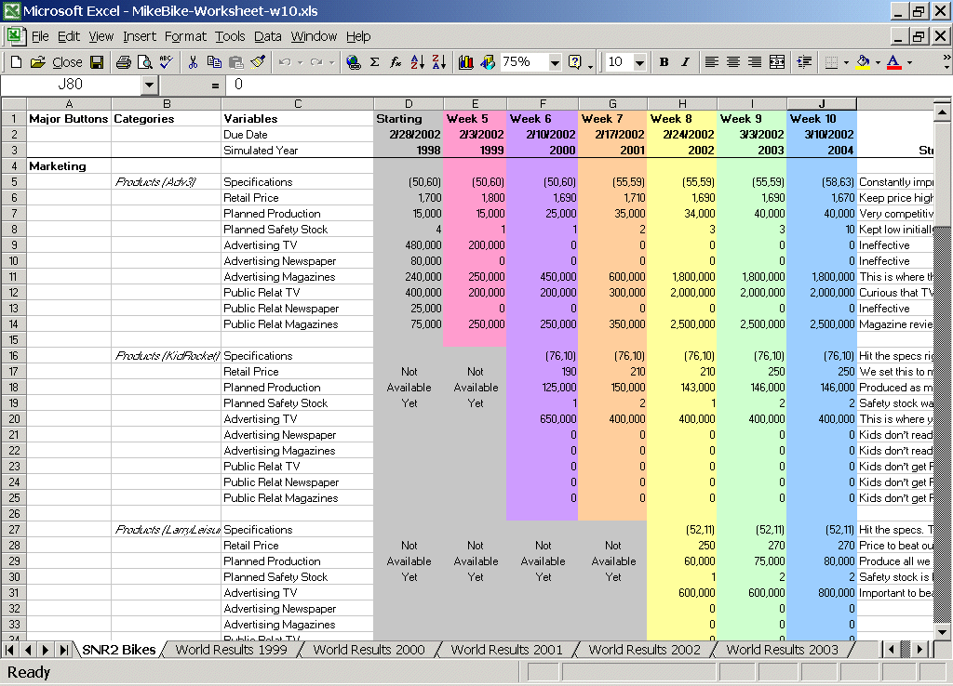
As part of our final report we turned in our spreadsheet to WebTycho/UMUC. Perhaps they will give you this format to start with and you will not have to make your own from scratch.

Figure 3. SNR2 Team’s Input/Output Tracking Spreadsheet

- Strategic Plan

In our world, all four companies started with an identical product in the Adventure market. You need to decide what part of the market you want to move into. You can capture multiple segments, no need to limit yourself to just one.

Our experiments indicated that it was best to keep the Adventure bike in production even after you have moved into a new segment.

- The Advisor of Oz

NetMike has an Advisor that is rather helpful on your first move or two. It uses some simple rules to select a pre-written phrase of advice. It is like a fancy “Magic 8 Ball” toy. Initially this can be helpful in reminding you about issues you may have missed. However, reading the extensive list of reports is much more instructive. Eventually you should ignore the Advisor. If you are getting good at the game its advice will seem trivial.

- Design & Development

We worked through the input options beginning with Design and Development and working our way backward to Products. We considered the D&D decisions to be the most strategic and those that we would execute and stick with regardless of their immediate financial impacts.

First, you should consider starting a D&D project on EVERY turn. The D&D project may create a new bike in a new market segment or it may simply improve the design of an existing product. Eventually you will run out of good applications of D&D. But at the beginning you should use it every time.

There is a formula in the NetMike manual that shows you how much it will cost to create a new bicycle. The cost is based on your current set of products and the specs of the resulting bike. You do not have to guess at this, the formula will tell you what to do. During the experiments you can learn to hit your objective bicycle at 100%.

We discovered several strange behaviors in the D&D algorithms. It is sometimes impossible to make very small adjustments to existing models of bicycles.

- Finance – Equity, Debt, Investor Relations

As you know by now, in business idle cash is bad. If your company is making a profit you need to apply this money to some useful mission. In our game, we initially spent our profits to pay-off our long-term debt.

Once that was done we used the money to buy back stock. During the year that you execute the buy back your stock price will drop because you have less profit. But in the following year it will take a significant jump. Also, once the stock is repurchased, this will improve your stock performance for every year thereafter.

If your company is performing well you need to spend generously on Investor Relations. This represents communications with Wall Street and institutional investors. This will magnify your performance and drive up the stock price. This is where the hype behind stocks like Palm, Netscape, and Amazon came from (even before they had profits).

We do not know how spending on Investor Relations effects a company that is doing poorly.

We never paid a dividend. The market seemed to prefer that we keep the cash and invest it in the company. It appears that the company was making higher returns than alternative that stockholders could have placed the dividend money in.

- Manufacturing

There are a lot of variables in this section. It is important that you increase your production SCU to service the markets you are moving into. There are some details in the manual about the amount of SCU you need for each bike (e.g. $300 in prime cost = 1 SCU). But conducting experiments and reading the resulting reports will show you whether you have enough SCU. It is important to buy SCU the year before you really need it. So SCU purchases should be linked to D&D projects. That way, when the new bike model hits the market your manufacturing capacity is online.

The number of employees also limits production. But we could never figure out how many employees were right for a given manufacturing SCU. There is some gobbledy-gook in the manual that makes no sense at all. So we were shooting in the dark and using the experiments to discover the right level.

Batch Size needs to go higher. Since we moved into the low-end market - Kids, Leisure, and Commuter bikes - we drove batch size up to 2200. That is probably too high for a company specializing in Adventure or Racing bikes.

Supplier Relations is a wonderful variable. You are paying your suppliers to give you good service (capitalism at its purest.) Be generous here until you nearly eliminate Raw Materials Stock Out in your Manufacturing Capacity Usage chart.

Salary. We all want to be generous to our hard working employees. But after an initial salary increase we never raised salaries again. We increased training to make the staff move competent – but then lowered it again. Training is useful when you have sufficient manufacturing capacity to meet demand. But when you need people working all the time to keep products coming out you have to reduce training time. We pushed it down 2 hours each year until we reached 34 hours and left it there.

Preventative Maintenance needs to go up when you increase the size of your factory. Also, never let this number go below $850,000.

Quality Systems and Inspections are directly linked. You want to spend money on Quality Systems to enable you to lower your inspection rate. Inspecting your products is extremely expensive and an investment in Quality Systems will more than pay for itself.

- Branding

This is like Nike putting their logo on NFL jerseys or their very esoteric ads that do not reference any products. Setting this number was also very mysterious. We kept raising it until we arrived at $900,000. That seemed to be all that did us any good.

- Distribution

If you are selling your products through retail chains you have to let those retailers keep a percentage of revenues. We experimented with this and discovered that they did not need 50% as it was set when the game started. We got down into the 20’s and were doing just fine. Similarly, we lowered the Extra Support amounts. We suspect that these numbers should be lower in the low-end market and higher in the high end. Racers and Adventures can probably not drop as low as we did.

- Products

Now we are finally at the actual products. Price is a very competitive item. If you want to charge a higher price you have to provide a better product or better service. We watched the market’s preference on Adventure bike specs and when it moved significantly away from our bike’s specs we started a D&D project to adjust the product. By the end of the game we had applied 3 new designs to the Adventure bike to make it the best (in terms of customer expectation) on the market.

Your safety stock determines how good your service is to customers. A couple of weeks always seemed to be the most profitable for us. We did not have the best delivery measure, but raising safety stock led to storage costs which lowered our profits and stock price. So we sacrificed some sales in order to avoid excess storage costs. (You would only know about storage costs if you read the manual.)

Advertising and PR. Each market segment responds to a different type of advertising and PR. The low-end market responds to television advertising. Kids bikes do not respond to PR at all. Leisure and Commuter customers like to get their PR from the newspapers. The amount of advertising/PR you need is strongly influenced by the competitors you have in a market segment.

You can modify an existing bicycle. First you have to complete a D&D project in the same market segment. Then you can change an existing bike model. You should know that when you change the model, the simulation will dump all remaining inventory of the old model at cost.

In the early moves of the game you should be launching a bike or modifying one on every turn.

We experimented with abandoning our Adventure bike. The results were always disastrous so we never did it.

- Perceptual Map

The perceptual map is a really nice graph of where your customers are. If you read the formulas in the manual you should be able to place your products on the bulls-eye every time. You should not accept any D&D that does not hit the bulls-eye 100%. However, each year the customer’s preferences will change slightly. We used D&D to modify existing products when they were at about the 85% level of matching customer desires.

- Reports

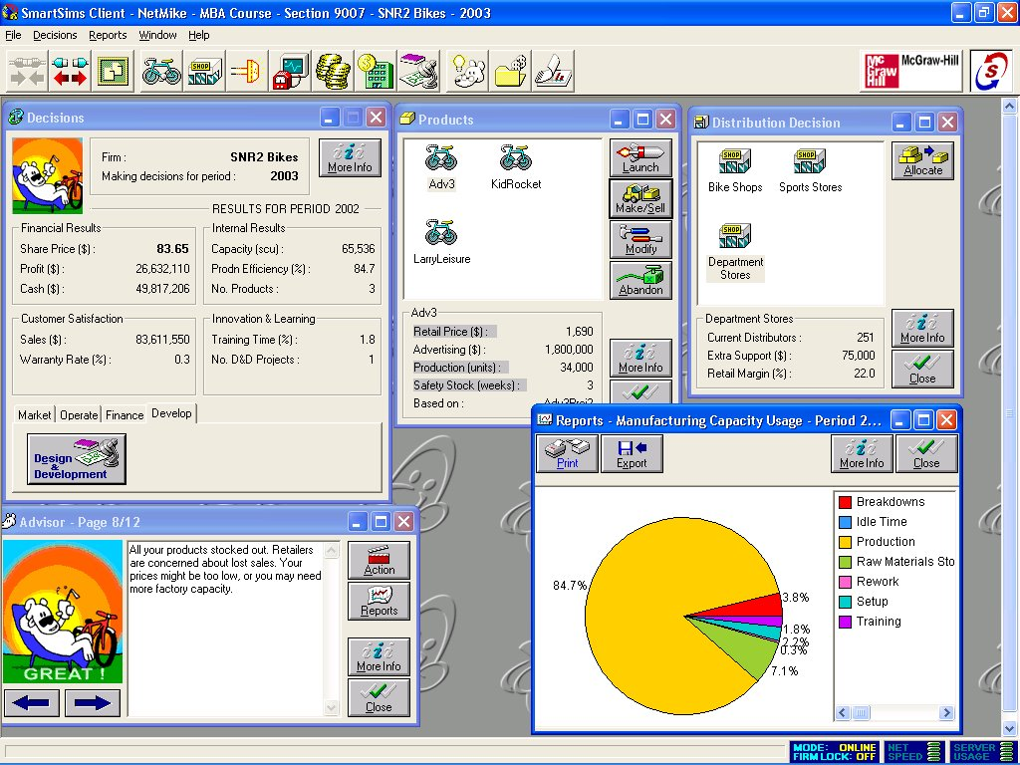
NetMike generates a lot of reports. Some of them are more informative than others. You will spend a lot of time reading these in the beginning. But you will get through them faster each week. Here are the ones we found the most useful. You will find these if you select “Reports” >> “Flick All Reports” from the menu.

Figure 4. NetMike Reports and Advisor

First Tier – These are really important

Manufacturing Capacity Usage (and Manufacturing Responsiveness). You want to spend as much time as possible in production. Adjust your Operations variables to eliminate the different sources of downtime. (There are some tricky exceptions to this rule, but we will let you discover them yourself.).
Market Share. This tells you how much of the market you are capturing. If this number is not going up you need to conduct more experiments before committing your move and read the manual.
Products – Sales, Margin, Production. On this report pay particular attention to the number of units you produced and the number of “Lost Sales”. If you are losing sales you need to either increase production or raise prices. Then look down at your gross margins. We tried to keep ours between 60 and 70%. Even if you have no competition in a market you need to stay in this range. In the one case where we violated this rule a competitor came in at a significantly lower price and ate our lunch. (If we had avoided this we may have hit a stock price in the $200’s.) Then look down at your Delivery Performance Index. Getting a 1.0 is ideal, but you just want to stay near that number. If it drops too low then you need to increase your safety stock for that bicycle (in the Products menu).
All Product Details. This is the most important report. It shows how you are doing relative to the competition. You can see if they are selling lower, delivering better, or advertising more. It is a great guide to how to react to them.
Cost of Quality. Check the Inspection cost versus the Quality System costs. Try to spend on Quality and save on Inspection. We often found that a $100,000 investment in Quality would allow us to lower Inspections by 1% and save several hundred thousands of dollars in inspection costs.
Multifirm Retailer Margins and Extra Support. This shows how well you are paying retailers relative to your competitors. You want to move down below the starting 50%. Remember that the money that you pay retailers comes out of your profit. This is not a game of charity, cut them down until it starts to negatively impact your profits because they are not selling your bikes.
Product Development Project Results. This shows you how well your D&D worked out. Never accept less than 100%. Read he manual and experiment until you can hit 100%.

Second Tier – There are next in importance

Financial Results of All Firms.
Multifirm Profit.
Multifirm Sales Revenue.
Multifirm Shareholder Value.
Activity Cost Drivers.
Product Customer Values.
Market Segments and Product Attributes.
Manufacturing Quality Report.

Ignore the Rest

There are a lot of reports in NetMike that we never looked at or never learned anything from. Curiously, many of these useless reports are the ones that are required in every company’s annual report. I wonder if that means anything.

- The Competition

We ran many experiments to optimize our performance, but these simply project the competitors’ existing values forward. After you have identified the optimum variables you need to sit back and think about what your competitors will do on this move. Will they enter your market at a lower price? Will they improve their advertising in Adventure bikes? Will they improve their distribution to customers?

These thoughts will lead you to modify your decisions about the price of the product, advertising and PR levels, and safety stock. This will almost always lower the online projections of your stock price, but you have to take actions to counter what you expect the competition to do.

For example, we saw that another company was had one market segment to themselves and was charging an exorbitant price for bikes. This was a perfect opportunity for us to move in and undercut them. We grabbed most of the market away from them. Then we forgot this rule a couple of weeks later and another company did the same to us.

We owned the Kids market through the entire game, but were constantly afraid that a competitor would enter it. So every move we lowered prices or improved the specs of the bike. No one ever entered the market. Perhaps our preemptive actions kept them out.

The best possible world is where no competitor enters your market area. But, if there are multiple companies in one market you have to improve your product through D&D, improve your factory efficiency, improve delivery of the product through the right safety stock, and lower your price.

- Monday Morning

Our final moves were due on Sunday night. Every Monday morning I got up and got on the computer to see how our company did. It was exciting to find out. Because we worked so hard to select our move, and sometimes because we were lucky, we always had encouraging news on Monday morning. If you get involved in the game you will get excited about it and positive results will fuel your enthusiasm.

What a great learning experience!

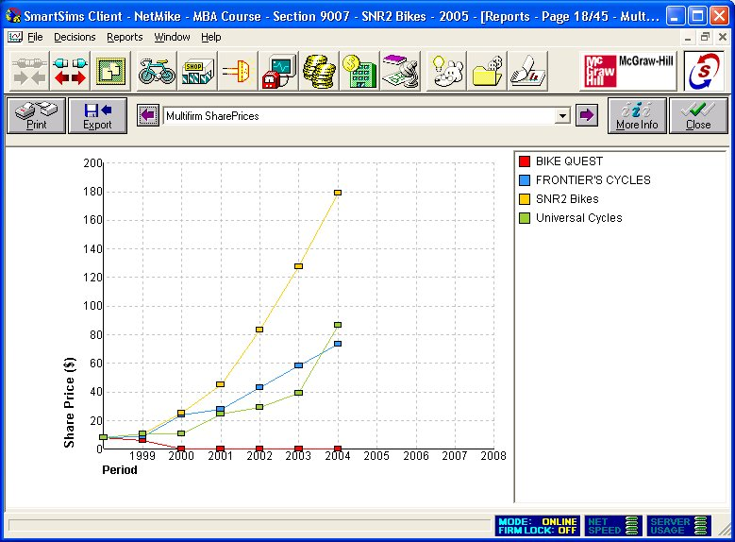
Figure 5. Final Share Prices of Teams Competing Against SNR2

The screenshots shown in this report come from SmartSims’ NetMike software. The software and the screenshots are copyrighted by SmartSims and McGraw-Hill-Irwin. http://www.smartsims.com/

